**CURRENCY CONVERTER**

**END TERM REPORT**

***by***

**Varun K, Ranjith Varma, Ajith Reddy**

Section: **K19QK**

Roll Numbers: **RK19QKA17, RK19QKA12, RK19QKA13**.



**Department of Intelligent Systems,**

**School of Computer Science Engineering,**

**Lovely Professional University, Jalandhar**

November, 2020

**Student Declaration**

This is to declare that this report has been written by me/us. No part of the report is copied from other sources. All information included from other sources have been duly acknowledged. I/We aver that if any part of the report is found to be copied, I/we are shall take full responsibility for it.

Name:

Varun.k, Ranjith varma, Ajith reddy

Roll Number: RK19QKA17, RK19QKA12, RK19QKA13.

**TABLE OF CONTENTS**

**TITLE PAGENO.**

***Background and objectives of the project* 4**

**1.1 AIM OF THE PROJECT 4**

**1.2 Learning outcomes 4**

**1.3 Steps to build the project on currency converter 5**

**1.4 What is an API? 5**

***Description of the project* 6**

**1.5 Prerequisites 6**

**1.6 Real time Exchange rates 6**

**1.7 Import the libraries 6**

**1.8 JSON Output 6**

**1.9 Python code 7**

**2.0 Output of the code 9**

**1.BACKGROUND AND OBJECTIVES OF PROJECT ASSIGNED**

**1.1 AIM OF THE PROJECT :**

**Our aim is to create a currency converter to help us convert a sum of money from one currency to another**.

Currency exchange rates are constantly changing which is why we have decided against the idea of storing all the exchanges rates in our code are these would not remain up-to-date. Instead we will retrieve up-to-date currency exchange rates by making calls to an API that provides the current rates.

To do so we will use the **“Currency Converter API”** to retrieve up-to-date exchange rates. You can read more about this **API** on:

**“**[**https://api.exchangerate-api.com/v4/latest/usd**](https://api.exchangerate-api.com/v4/latest/usd)**”.**

A currency converter could be really useful to anyone who needs to monitor currency fluctuations and it’s measuring. In the online world, you could find a lot of currency converters out there but if you need a personalized converter for your pacific needs, you need to consider building one.

**1.2 LEARNING OUTCOMES  
At the end of this Project you will be able to know:**

1. **What is an API?**
2. **How you could simply use it using python!**
3. **How to build a custom currency converter.**

**To create the converter we have used the open-source  Exchange rates API** [https://api.exchangerate-api.com/v4/latest/usd](%20https://api.exchangerate-api.com/v4/latest/usd)).

It is pretty simple to use. You just need to give the base URL; add some parameters and you will get the exact response to play around with. For example, to get the latest or historical currency value, you need to add the desired

data, base currency like USD or POUND, desired currency value like INR and that’s it. You will get the response. After this, you can extract the data from this response using a request. Json method

**1.3 Steps to Build the Python Project on Currency Converter**

1. Real-time Exchange rates
2. Import required Libraries
3. Currency Converter Class
4. UI for Currency Converter
5. Main Function

**1.4 Firstly, what is an API?**

As all of you know API is the application programming interface. It helps computer programs to communicate and share data. It is like a railway track using which data can be transferred from one station to another station.

Through API the data always transferred in the JSON (JavaScript Object Notation) format. to use that data, you need to convert it to a suitable format and then use it.

**How you could simply use it using python:** In python, there is a very simple library called **request**. To get the data, you just need to use the.get method and then convert it to python dictionary data type using the **.json** method. You could also use Python’s own **JSON** package**. loads** method for the same.

**2.Description of Project**

**1.5 Prerequisites**

The currency converter project in python requires you to have basic knowledge of python programming and the pygame library.

* requests – to get URL

#### **1.6 Real-time Exchange rates**

To get real-time exchange rates, we will use: https://api.exchangerate-api.com/v4/latest/USD

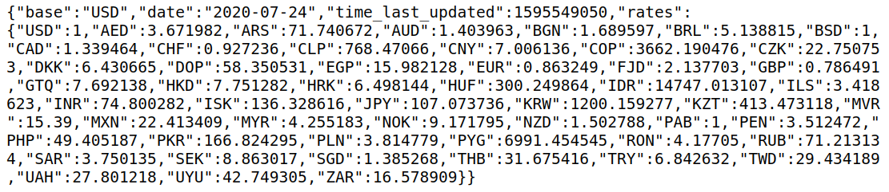

Here, we can see the data in JSON format, with the following details:

**Base – USD:**It means we have our base currency USD. which means to convert any currency we have to first convert it to USD then from USD, we will convert it in whichever currency we want.

**Date and time:** It shows the last updated date and time.

**Rates:** It is the exchange rate of currencies with base currency USD.

#### **1.7 Import the libraries:**

For this project based on Python, we are using requests library. So, we need to import the library.

##### ***1.8 JSON Output***

This API uses **JSON to format the data**. JSON (JavaScript Object Notation) is a popular lightweight data-interchange format. Its main benefit is that it is easy for humans to read and write and it is easy for machines to parse and generate as you can see in the code provide below. You can read more about JSON on <https://www.json.org/>

**1.9 Python Code**

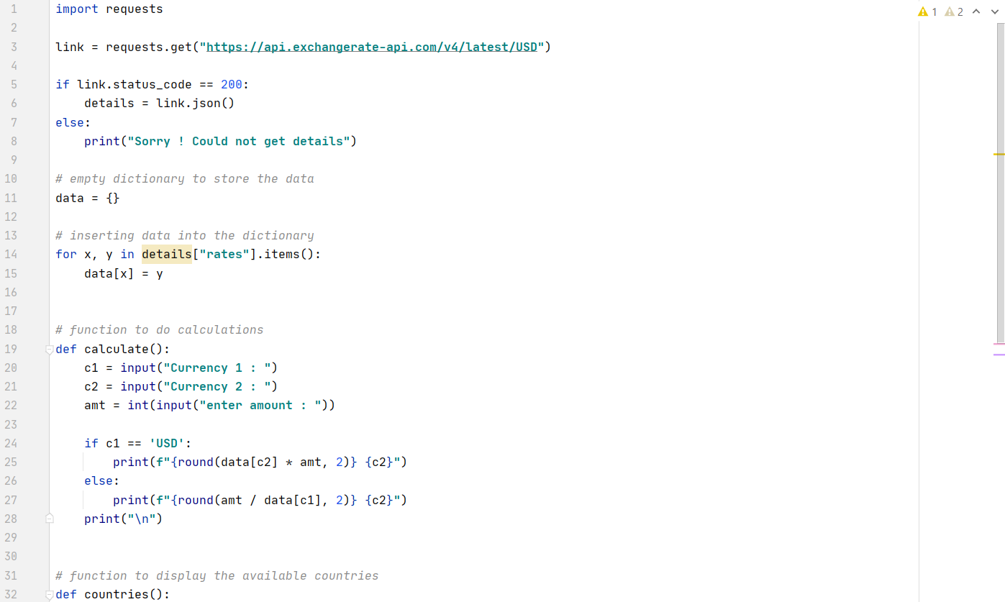

Always check if the response status code is 200. If it is not, you will not get anything out of it.

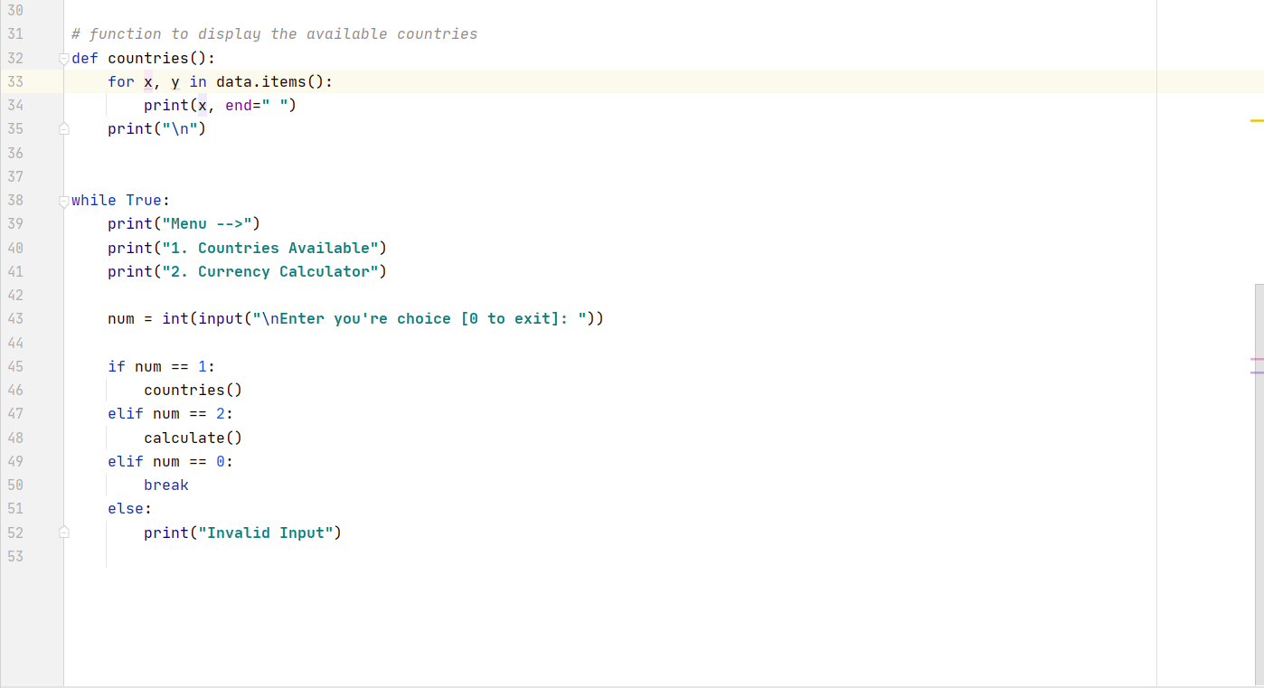

**2.0 Output of the code**

